PYTHON FOR DATA ANALYSIS PROJECT REPORT
Submitted by:
• Name: P.B.PRAVIN

• Register No: 26 BSC 091
- Google Colab

https://colab.research.google.com/drive/1Q7AZ62XmiFN5ZSsvMvOZnhxign_Z84DO#scrollTo=PK6cduXZsMhKSection 1 — Objective
The objective of this analysis is to study Shopify Inc. (SHOP) historical stock-price movement, trading volume, moving averages, daily-return distribution, and volatility. The analysis uses the supplied daily CSV data containing date, open, high, low, close, adjusted close, and volume.

Section 2 — Historical Price Trend
The dataset contains 2,469 daily observations. The closing price was $2.57 at the beginning of the period and $94.85 at the end. The highest closing price in the dataset was $169.06 on 19 November 2021, while the lowest was $1.93 on 12 February 2016. From the first to the last observation, the cumulative change in closing price was 3593.54%
SHOP Closing Price Historical Trend (2015-2025)
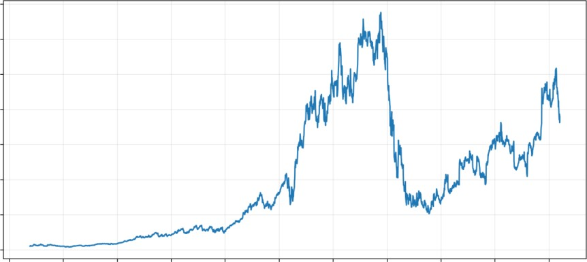
175
150
125
2 100
? 75
50
25
o
2015 2016 2017 2018 2019 2020 2021 2022 2023 2024 2025
Date

Section 3 — Trading Volume Analysis
Trading volume measures the number of shares traded during each trading day. The maximum daily volume in the supplied dataset was 208,959,000 shares on 04 October 2017. Large volume values indicate periods of unusually active trading, while lower values indicate relatively lighter activity.
les SHOP Trading Volume Trend (2015-2025)
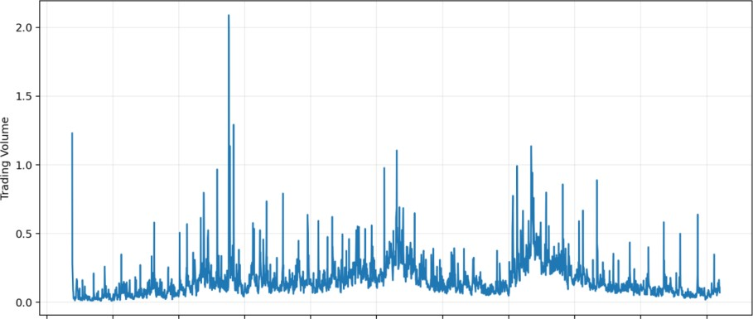
2015 2016 2017 2018 2019 2020 2021 2022 2023 2024 2025
Date

Section 4 — Moving Average Analysis
A moving average smooths short-term price fluctuations and helps show the underlying direction of the series. This analysis uses a 20-day simple moving average (20-Day SMA) and a 50-day simple moving average (50-Day SMA). The 20-day SMA responds more quickly to recent price changes, while the 50-d
SHOP Closing Price with 20-Day and 50-Day SMA
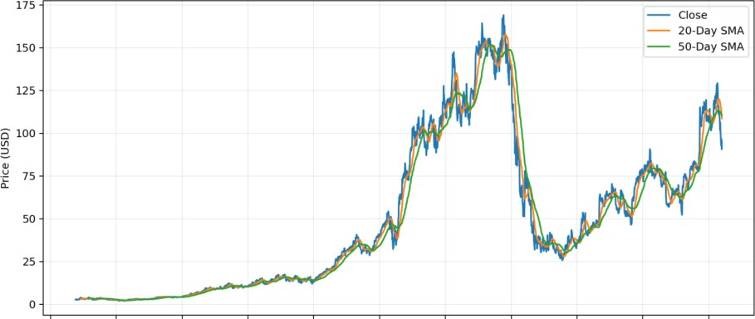
2015 2016 2017 2018 2019 2020 2021 2022 2023 2024 2025
Date
ay SMA provides a broader view.

Section 5 — Return Distribution
Daily returns were calculated as (Today's Close / Previous Trading Day's Close) — 1. The average daily return was 0.215%, the median was 0.204%, and the daily standard deviation was 3.712%. There were 1,313 positive-return days and 1,149 negative-return days.
SHOP Daily Return Distribution
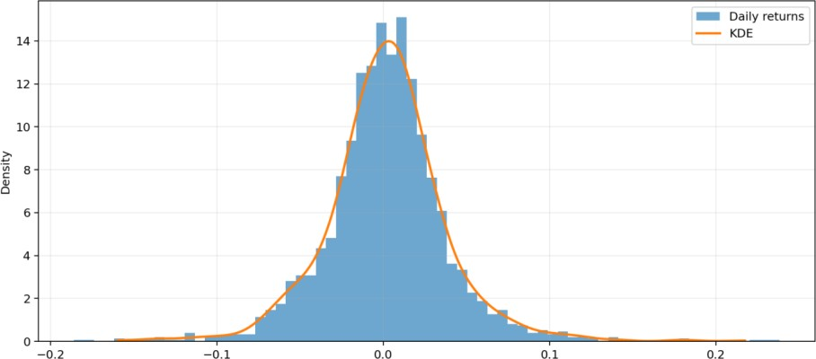
Daily Return

Section 6 — Volatility Analysis
The standard deviation of daily returns was 3.71%, corresponding to an annualized volatility of approximately 58.93% using V252. For identifying individual high-volatility days, the analysis ranks observations by absolute daily return
SHOP 20-Day Rolling Annualized Volatility
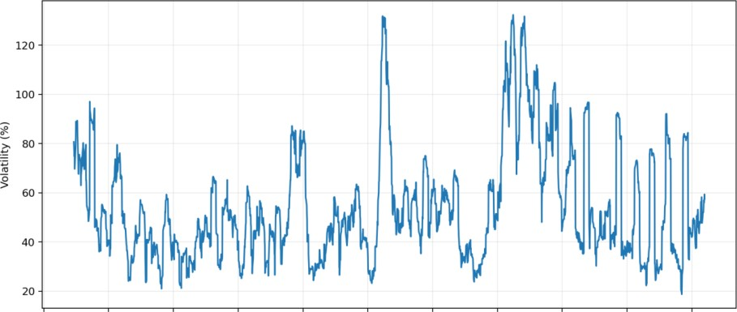
2015 2016 2017 2018 2019 2020 2021 2022 2023 2024 2025 Date
Top 5 largest positive daily returns:
04 May 2023: 23.84% (close $57.30) 17 sep 2015: 22.97% (close $3.56) 02 Nov 2023: 22.36% (close $59.70) 12 Nov 2024: 21.04% (close $108.92)
18 Mar 2022: 18.65% (close $78.00) Top 5 largest negative daily returns:
08 May 2024: -18.59% (close $62.73) 16 Mar 2020: -17.55% (close $32.23) 16 Feb 2022: -16.04% (close $74.68)
16 Feb 2023: -15.88% (close $44.91)
05 May 2022: -14.91% (close $41.31)

Section 7 — Key Financial Insights
The closing price increased from $2.57 to $94.85 across the supplied period, a cumulative change of 3593.54%.
The dataset's maximum closing price was $169.06 on 19 November 2021; the minimum was $1.93 on 12 February 2016.
The largest daily positive return was 23.84% on 04 May 2023, while the largest daily negative return was -18.59% on 08 May 2024.
The maximum daily trading volume was 208,959,000 shares on 04 October 2017, showing a day of unusually active trading in the supplied data.
The maximum peak-to-trough drawdown in the sample was 84.82%, from the peak on 19 November 2021 to the trough on Il October 2022.
The 20-day and 50-day SMAs provide different smoothing horizons: the 20-day average reacts faster to recent movements, while the 50-day average changes more gradually.

Section 8 — Conclusion
The supplied SHOP data shows a long history of substantial price movement, including periods of strong appreciation, sharp declines, and elevated volatility. The closing-price chart describes the long-term path, trading volume highlights periods of active market participation, moving averages smooth short-term fluctuations, and return/volatility analysis quantifies day-to-day variability. Together, these measures provide a structured description of the stock's historical behavior during the supplied period. Historical performance and volatility do not by themselves determine future results.

